La crise catalane est née à Madrid
Opposés sur la question de l’indépendance catalane, les dirigeants politiques au pouvoir à Barcelone et à Madrid se ressemblent : ils estiment que leur intransigeance fera oublier les scandales de corruption qui les accablent. Un bouillon de culture propice aux surenchères, y compris répressives. Imaginer une solution au conflit implique au contraire de remonter aux racines de la crise.

The Catalan crisis was born in Madrid
Opposed on the issue of Catalan independence, the political leaders in power in Barcelona and Madrid are similar: they believe that their intransigence will make forget the scandals of corruption that overwhelm them. A cultural broth conducive to overbidding, including repressive. Imagine a solution to the conflict implies, on the contrary, to go back to the roots of the crisis.

U Katalan krisi pa gene nati in Madrid
Plu krati-co politika duce-pe in Barcelona e Madrid akti opositi-co de u qestio de Katalan no-pende. Sed mu es homo alelo: mu kredi; ke mu non-flexi-etos fu sti no-memo plu skandali de korupti; qui tempestu mu. Id es u kultura supa prono a plu hiper-force-akti, klu u opresi-akti. Anti-co te imagina u solve ad u disputa, pe nece retro a plu radi de krisi.

Un Ursu e bi Viagia-pe

U nara de Aesop ge-translati de Ian Niles
Bi andro pa du viagia kon alelo, kron un ursu subito monstra se epi mu via. Mo ex plu viagia-pe pa skende ad-in dendro e kripti se in plu rami. Un hetero viagia-pe, tem vide; an sio gene viole, kade plati ad-epi solu. Kron un ursu pa veni, palpa an per auto rino, e nasa an panto-lo, u viagia-pe sto spira e sti feno iso multi de posi; an es morta. Un ursu tosto lase an, ka pe dice; ursu ne palpa morta soma. Kron an ki ab, un hetero viagia-pe ki kata ex dendro e komika qestio ad auto ami; qo-ra un ursu pa susura in an oti. “An pa dona a mi u-ci monito,” an ko-pe pa reakti. “Nuli-kron viagia kon ami, qi lase tu kron risko veni.”
Morali es; mali fortuna proba un honesti de ami.
In English: https://fablesofaesop.com/the-bear-and-the-two-travelers.html

Marea
Plu marea es plu ana e kata de libelo de mari kausa plu ge-kombina efekti de plu gravita tenta ge-akti ex u Luna e ex un Helio e plus kausa u gira de u Geo.
Plu tem e u amplituda de plu marea in uno ge-dona topo es ge-influ ex u alinea de un Helio e de u Luna, ex u marea ordina in u profunda oceani, ex plu peri-dromo sistema de plu oceani e ex forma de u litora et de u proxi-litora bato-metri. Plu-uno litora-line experi u semi-singu-di marea — bi ana e kata marea singu di; qi es proxi eqa. Plu hetero topo experi u singu-di marea — solo mo ana e kata marea singu di. U “ge-mixa marea” — bi no-eqa marea singu di, alo mo ana e mo kata — es plus posi.
Plu marea vari epi tem-skala ab plu horo a plu anua kausa poli faktora. Te face plu exakti note, plu marea-metri in plu ge-fixa statio metri u aqa libelo iso funktio de tem. Plu metri ignora plu vari ge-kausa ex unda ko itera-tem ma brevi de plu minuta. Plu-ci info gene kompara a u basi libelo (alo “datum” libelo), more-co ge-nomina u meso mari libelo.
Klu si id es plu marea; qi es u ma important origi de plu brevi-tem vari de mari-libelo, plu mari-libelo es plus ge-influ ex plu dina tali iso u venti e plu baro-metri vari de presa, e plu-la sti surge de plu tempestu, speci in no-profunda mari e proxi litora.
Plu feno-acide de marea ne es ge-limita a oceani, sed posi acide in plu hetero sistema ali-kron u gravita agri es la; qi vari in tem e in spaci. Speci, u solidi mero de u Geo es ge-influ ex marea, anti-co te vista id ne es iso facili de vista u marea kine de aqa.

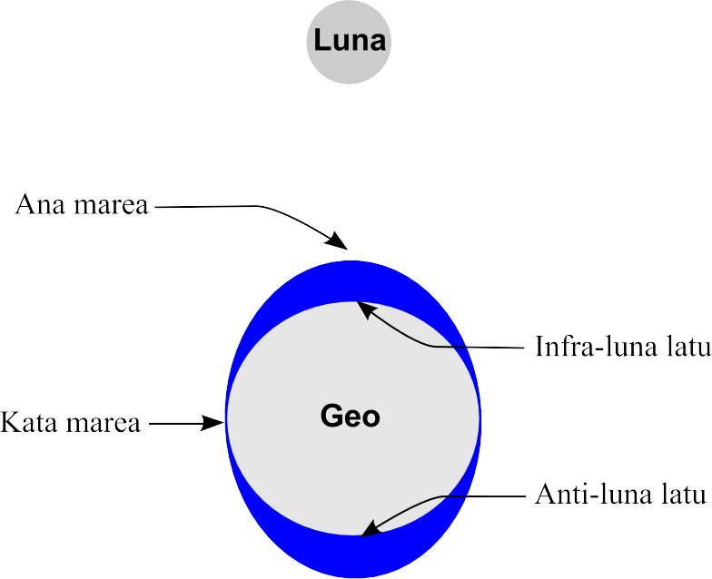
* * *
English fonta ex Wikipedia: https://en.wikipedia.org/wiki/Tide
* * *
Plu skience-verba: marea “tide”, skience-verba “(scientific) term”, tenta “force”(in newtons) (as opposed to dina “power” (in watts)), tem “time” (in seconds), taxo “pattern, arrangement”, peri-dromo “amphidromic, lit. “running around” ”, bato-metri “bathymetry, lit. “measuring the deepness” ”, singu-di “diurnal, lit. “daily” ”, tem-skala “timescale” singular, iso funktio de tem “(measure smth.) over time, lit. as a function of time”, itera-tem “period” (as opposed to eva “lifetime, half-life, damping time”), baro-metri “barometric, lit. “pressure-mesuring” ”, feno-acide “phenomenon”, gravita agri “gravitational field”.

U auto-fide, ex Ralph Waldo Emerson
Ka-ce, uti u panto; qi sti nomina U Fortuna. Pleisto homi ludi ko fe, e mu gania u panto, e mu lose u panto, tem u Fe ciklo gira. Kontra-co tu, linqi plu-ci gania iso no-lice, e pragma ko U Kausa e U Seqe, plu krati-pe de U Teo. Ergo e procura in U Volu, e ex acti so tu gene katena u ciklo de U Okasio, e nuli-kron ma tu fu este fobo de plu id gira. U politika vikto, u kresce de renta, u konvalesce de tu pato-pe, alo u ki-versi ex viagia de tu ami, alo uno hetero favo acide… plu-ci ra leva tu spiritu, e tu puta; ke plu boni di gene prepara pro tu. Ne kredi id. Nuli-ra posi fero a tu u paci, exklude tu. Nuli-ra posi fero a tu u paci, exklude u fini vikto de plu tu principi.

Self-reliance, by Ralph Waldo Emerson
So use all that is called Fortune. Most men gamble with her, and gain all, and lose all, as her wheel rolls. But do thou leave as unlawful these winnings, and deal with Cause and Effect, the chancellors of God. In the Will work and acquire, and thou hast chained the wheel of Chance, and shalt sit hereafter out of fear from her rotations. A political victory, a rise of rents, the recovery of your sick, or the return of your absent friend, or some other favorable event, raises your spirits, and you think good days are preparing for you. Do not believe it. Nothing can bring you peace but yourself. Nothing can bring you peace but the triumph of principles.

Доверие к себе, Ральф Уолдо Эмерсон
Итак, поставь себе на службу все, что называют судьбой. Большинство людей играют с ней в азартную игру, и с каждым поворотом ее колеса кто-то приобретает все на свете, а кто-то все теряет, но ты научись считать эти приобретения незаконными и не стремись к ним, ты отдайся служения Делу и Пользе, этим канцлерам Всевышнего. Отдайся Воле, трудись, приобретай, и ты сумеешь сковать движение колеса Случая и не будешь страшиться нового его поворота. Когда тебе удается одержать победу на политическом поприще, когда ты добиваешься повышения своих доходов, когда кто-то болел у тебя дома и выздоровел, когда вернулся долго отсутствующий друг, когда произошло какое-нибудь другое приятное событие, тебя охватывает радость, ты мнишь, что впереди тебя ждет прекрасная пора. Не верь этому. Никто не вселит в твою душу мира, кроме тебя самого. Ничто не вселит в душу твою мира, кроме полной победы твоих принципов.

Simone Weil
Simone Weil pa gene nati in Paris tem 1909; e pa gene eduka in Ecole Normal Superieure, fe pa es mo de plu proto gina stude-pe la. Fe pa esce u doci-fe; sed plus-co, pa ergo in plu agri-lo e plu face-do; topo fe pa elekti de akti plu no-facili manu ergo te experie u bio de u norma ergo-pe. Tem 1936 fe pa es u membra de u Republika dina in Hispania Intra-Milita; fe pa ki versi ab ante-line po sufere u mali piro-noku in mal-acide. Tem 1942 fe pa ki ab ex France e pa es membra de Libe plu France-pe in London. U fu-anua fe pa lose bio ex tuberkulosis; fe ne pa sio vora ma sito de plu-la persona qi pa sufere ex Nazi okupatio in fe matri landa.
Fe plu grafo monstra; plu-la religio puta e idea qi pa veni ex poli speci fonta – Kristi, Semiti, India, Greko e Hindu – e foku a sufere e salva. U lekto-pe veni facia a facia ko homi konditio e ultra id.
«Te es ge-radi posi es u maxi importa nece e u mini famo nece de u homi anima».
«L’enracinement est peut-être le besoin le plus important et le plus méconnu de l’âme humaine».
“To be rooted is perhaps the most important and the least known need of the human soul.”
— Simone Weil

Infra-lo, ex Dante
In Glosa, u lisi lingua

Semi-via epi viagia de na vita
Mi pa trova se intra obskura silva,
Ka u rekti via pa gene lose.
No-facili es dice; qod id pa es.
U-ci horido silva, asper, sever,
Pensi de id re-nova un horor!
Tanto amer, qe mort es poko ma?
Sed te trata de boni mi pa trova la.
Fu dice de plu altri kosa mi pa vide la.
Ne pote re-dice komo mi pa entra la;
U-la momenta pa es tanto ple de somni;
Kron mi pa abandon u veri via.

It: Nel mezzo del cammin di nostra vita
mi ritrovai per una selva oscura
ché la diritta via era smarrita.
Ahi quanto a dir qual era è cosa dura
esta selva selvaggia e aspra e forte
che nel pensier rinova la paura!
Tant’è amara che poco è più morte;
ma per trattar del ben ch’i’ vi trovai,
dirò de l’altre cose ch’i’ v’ho scorte.
Io non so ben ridir com’i’ v’intrai,
tant’era pien di sonno a quel punto
che la verace via abbandonai.

En: Midway upon the journey of our life
I found myself within a forest dark,
⁠For the straightforward pathway had been lost.
Ah me! how hard a thing it is to say
⁠What was this forest savage, rough, and stern, ⁠
⁠Which in the very thought renews the fear.
So bitter is it, death is little more;
⁠But of the good to treat, which there I found,
⁠Speak will I of the other things I saw there.
I cannot well repeat how there I entered, ⁠
⁠So full was I of slumber at the moment
⁠In which I had abandoned the true way.

